
Year 11 Essentials

Mini Test 1.7

Interpreting and drawing Graphs
Name:________________

 | Total Marks: /29
Resources allowed: Calculator | Total Time: 30 mins | Weighting: 1%

- (9marks)
Complete the table
Data | Numerical or Categorical | Discrete or continuous | Best graphical display  (Line, bar, pie etc.)
Growth of a plant
Colours of Cars
Shoe sizes of students

- (9 marks)
Refer to the following graph
- What is the best-selling Fruit?  - How many lemons were sold in total? | 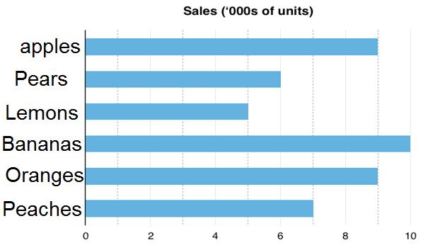 Type of fruit Amount of fruit sold
- How many fruits were sold in total?

- What percentage of the fruit sold were bananas? (2 decimal places)

- If pears were sold for $1.50 per fruit, how much revenue will be generated by the sale of pears?

- (11 marks)
The following table shows the average price of Unleaded Petrol for each day in the Perth Metro area for the past 2 weeks.

Month | Sun | Mon | Tues | Wed | Thurs | Fri | Sat | Sun | Mon | Tues | Wed | Thurs | Fri | Sat
Price(c) | 135 | 132 | 152 | 150 | 146 | 142 | 139 | 136 | 133 | 155 | 151 | 149 | 146 | 142
Source: https://www.fuelwatch.wa.gov.au/

- Represent this data in a line graph



- Which day of the week would you fill up on? Why?

- Which day of the week would you avoid filling your car up on? Why?

- Describe the trend of the fuel prices during this fortnight.

~End of Test~

